VisGrid - GUI for Selenium Grid

Contents

Setup for VisGrid: 3

Launch Hub: 3

Launch Node: 4

VisGrid

VisGrid is a GUI for Selenium Grid. You can start hub, create and attach a Selenium node very easily and quickly. VisGrid is a GUI tool to start/stop the Selenium Hub and to add/remove nodes to it.

# Setup for VisGrid:

1. Download and extract the latest VisGrid.zip from this Url : <http://www.codoid.com/products/view/2/30>
2. Double click on Visgrid.jar file

# Launch Hub:

1. Launch VisGrid.jar file and it opens a GUI grid setup window & automatically it makes the current system as Hub (consider system A) as default.

To start Hub click on “Start Hub” button.

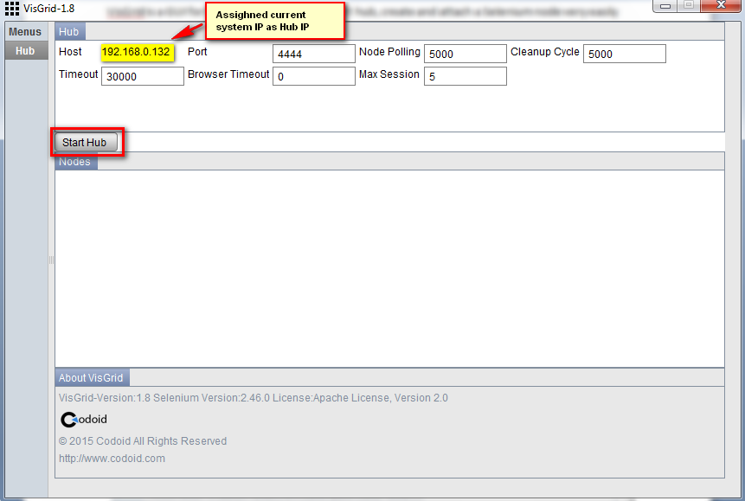

1. The Hub has launched successfully. Open <http://localhost:4444/grid/console> to make sure the hub is started.

# Launch Node:

Launching node in a system (Consider system B)

Once the UI was opened, you can create a node using ‘Create node’ button. But it creates node for the hub available in the same system (system B) as default. To change the Hub system (as System A) for this node i.e. to connect to the required hub system (System A), you need to override the Hub IP (System A’s IP) in respective test field.

You can set browser and other configurations in the same UI window and then click the add button.

Once you click the add button you can see an icon with port number which confirms the configuration of node connectivity to the hub.

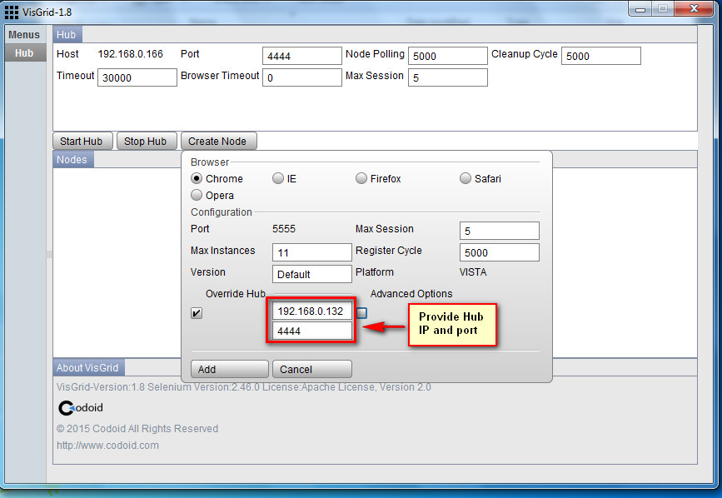

In below screenshot, you can observe that the node has launched successfully in system B for registered Hub (available in System A) with specified details.

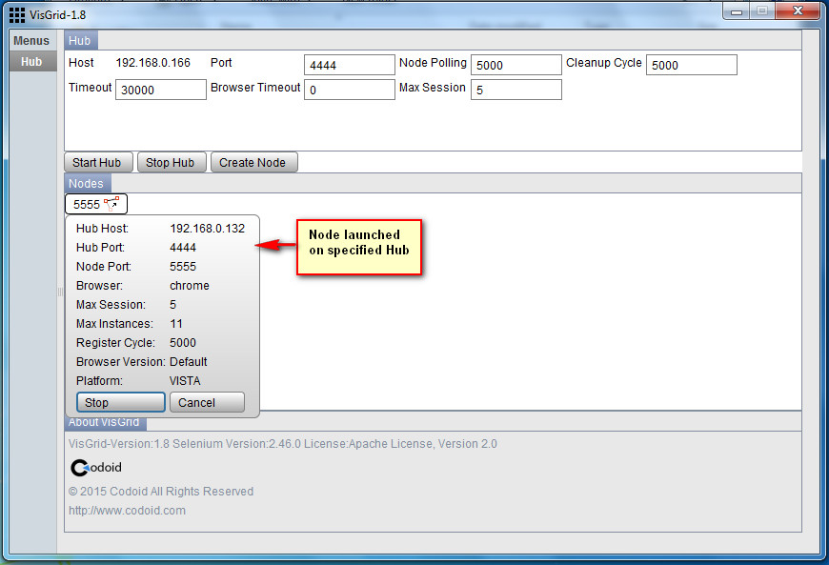

We can also verify the actions on Hub system by going through <http://localhost:4444/grid/console>

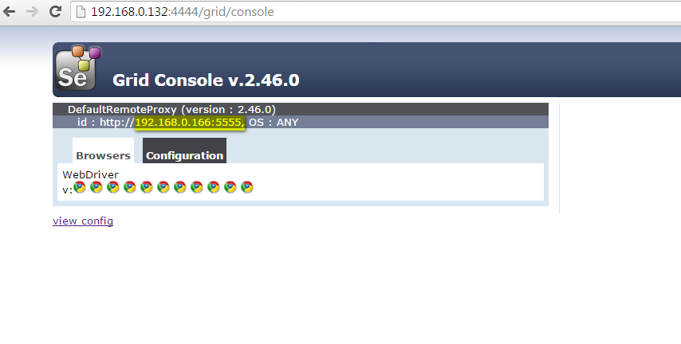 **Note**: We can launch ‘n’ no of nodes in ‘n’ no of machines against different browsers.